**Project Design Phase-II**

**Technology Stack (Architecture & Stack)**

|  |  |
| --- | --- |
| Date | 14 October 2022 |
| Team ID | PNT2022TMID48683 |
| Project Name | Early Detection of Chronic Kidney Disease using Machine Learning |
| Maximum Marks | 4 Marks |

**Technical Architecture:**

The Deliverable shall include the architectural diagram as below and the information as per the table1 & table 2

**Example:**

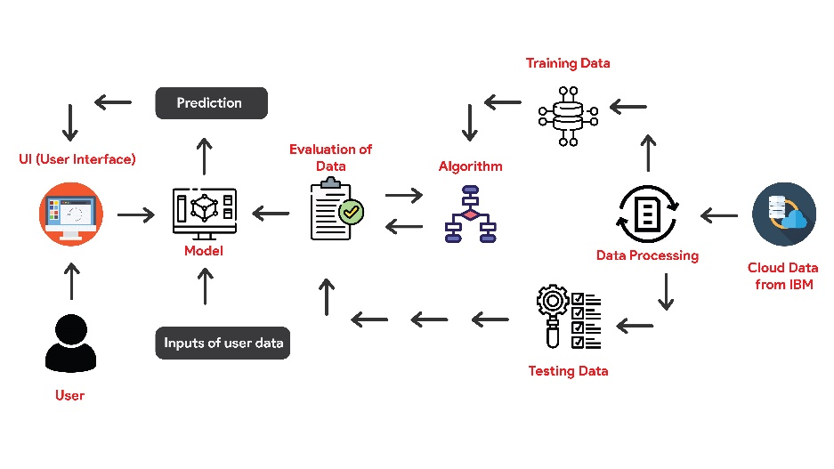

1. 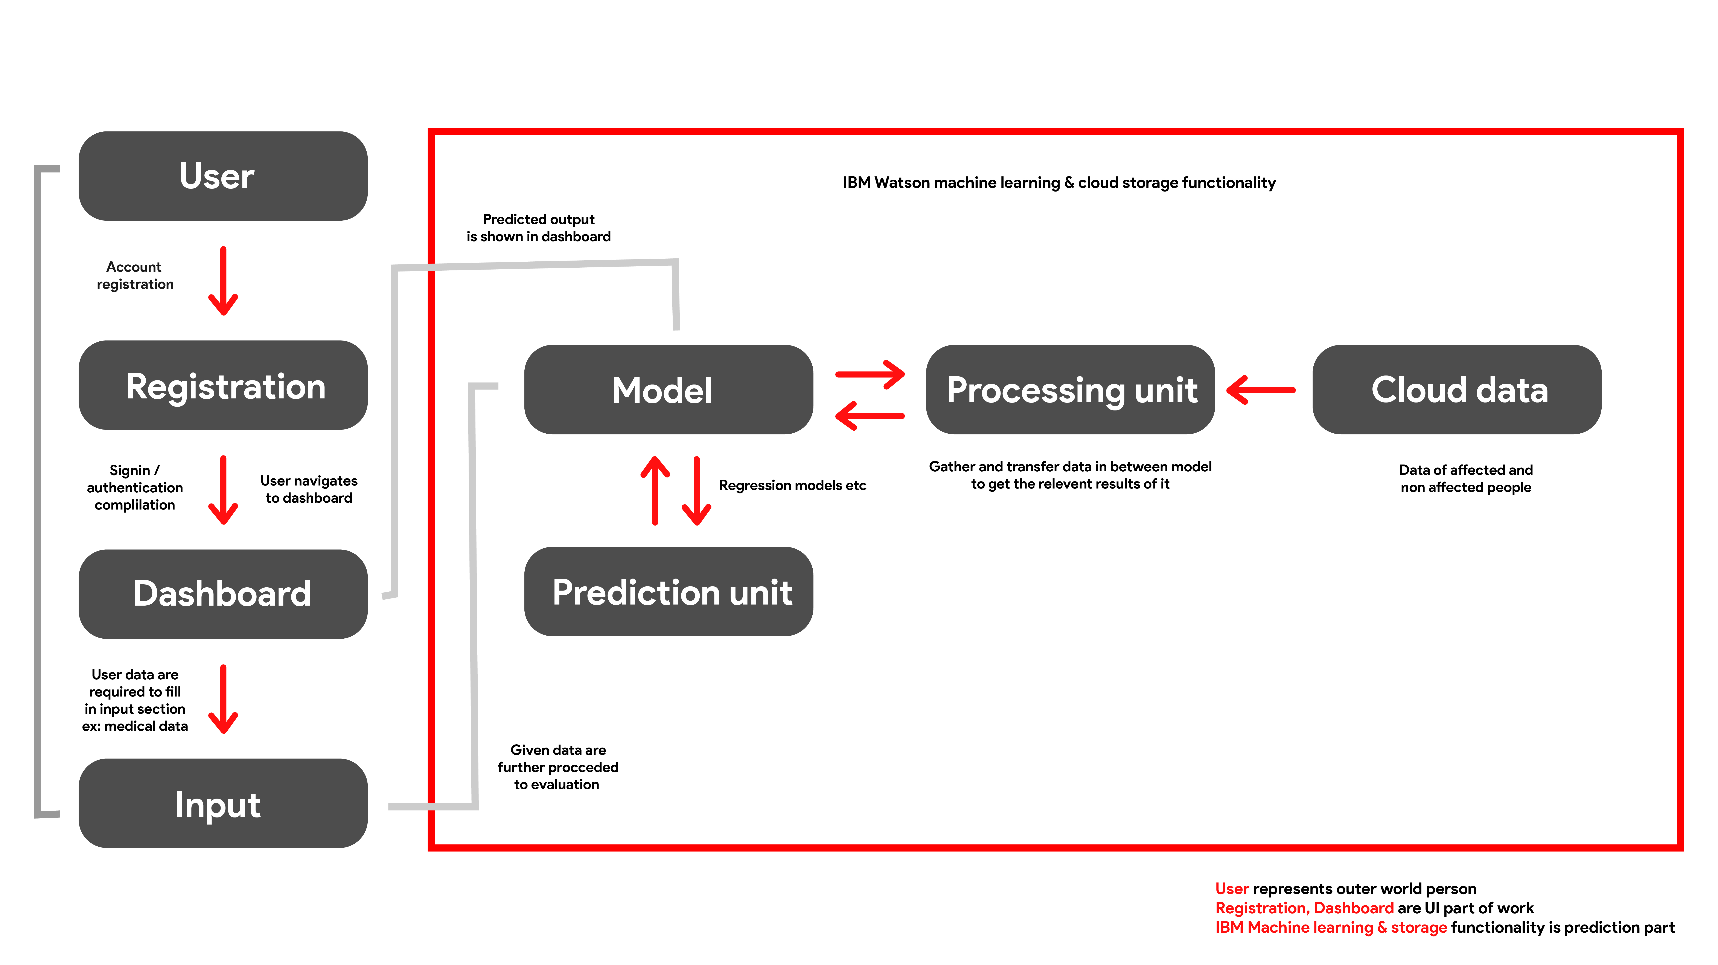

**Table-1 : Components & Technologies:**

|  |  |  |  |
| --- | --- | --- | --- |
| **S.No** | **Component** | **Description** | **Technology** |
|  | User Interface | Web UI, Mobile App | Flutter (Dart) |
|  | Application Logic-1 | To integrate API or API is directly used in flutter | Python |
|  | Application Logic-2 | To manage data package that initially stored in local | IBM Cloud object storage |
|  | Application Logic-3 | To predict and give the desired output of what we build for | IBM Watson machine learning |
|  | Database | Data is fed into watson cloud storage to process the data online in anytime in .csv format | IBM cloud storage |
|  | Cloud Database | Database Service on Cloud | IBM cloud storage |
|  | External API-1 | API used to gather the results that model predicts and also carry the output in dashboard of web or mobile application | IBM API |
|  | Machine Learning Model | This hard core part used to build the model based on application | Random Forest model |
|  | Infrastructure (Cloud) | Application Deployment on Cloud  Cloud Server Configuration: Firebase (Google) | Firebase |

**Table-2: Application Characteristics:**

| **S.No** | **Characteristics** | **Description** | **Technology** |
| --- | --- | --- | --- |
|  | Open-Source Frameworks | Flutter is open source UI frame work used now a days by many of the developers because it provides rich UI | Flutter (Dart) |
|  | Security Implementations | Since firebase is growing It provides best services for multiple platform applications with easy structural implementation | SHA certification in firebase |
|  | Scalable Architecture | Since we used flutter as UI frame work, It has the most advantages because it can be used to develop cross platform applications in single code base | Flutter and firebase |
|  | Availability | Application build for our project is hosted in web, mobile platforms | Web application, Play store, App store |
|  | Performance | The performance of flutter is best in market available at current time and also model that we build for machine learning given a well optimized performance with greater accuracy | Flutter, Random forest model in machine learning, ML deployment in IBM watson machine learning, Fire base for web and mobile application hosting |